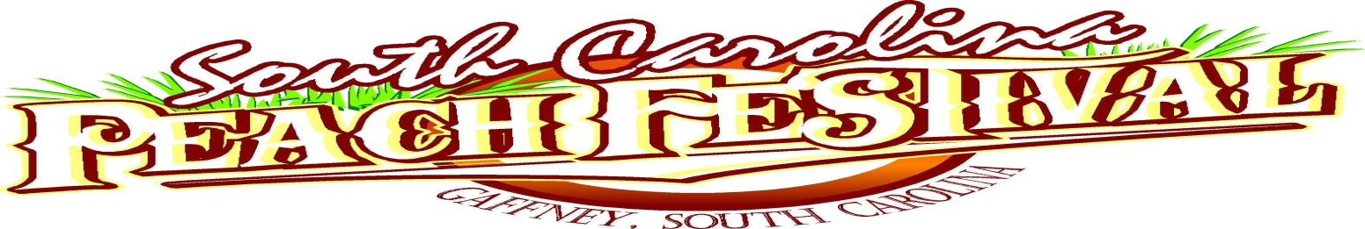
History
From an exciting weekend event in 1977 to this year’s extravaganza, the South Carolina Peach Festival has become the premier upstate summer event during July. As we celebrate our 41st anniversary, we do so with a smile at the countless events and people that has shaped this festival into what it is today.
The South Carolina Peach Festival first gained national attention in 1978 when volunteers gathered and spent hundreds of hours preparing ingredients in order to bake the World’s Largest Peach Pie. In 1981, dedication was held for the largest and juiciest of all peaches, the one million gallon water tank called ”The Peachoid” that sits stately along Interstate 85.
In 1989, the South Carolina Peach Festival broke the Guinness world record for having the most guitarists playing and vocalists singing the same song, Louie, Louie.” The event was broadcast on the nationally syndicated Guinness Records television show.
Then there are the concerts. The list of recording artist that have graced the South Carolina Peach Festival stage is too long to mention. From Garth Brooks, Reba McEntire, Charlie Daniels, George Jones and Tammy Wynette, to Kenny Rogers, Bill Pinkney and the Original Drifters, Ronnie Milsap, Jim Quick and the Coastline Band to Percy Sledge. Just to name a few of our all-time great entertainers.
This year, like all the years in the past, The South Carolina Peach Festival has something for everyone. From concerts, sporting events, a giant parade, arts and crafts, Crowning of our South Carolina Peach Queen, Mud Bogg, Peach Dessert Recipe Contest, world class wrestling and so much more.
Come one come all for the tastiest peaches anywhere and to experience Southern Hospitality at its best.

