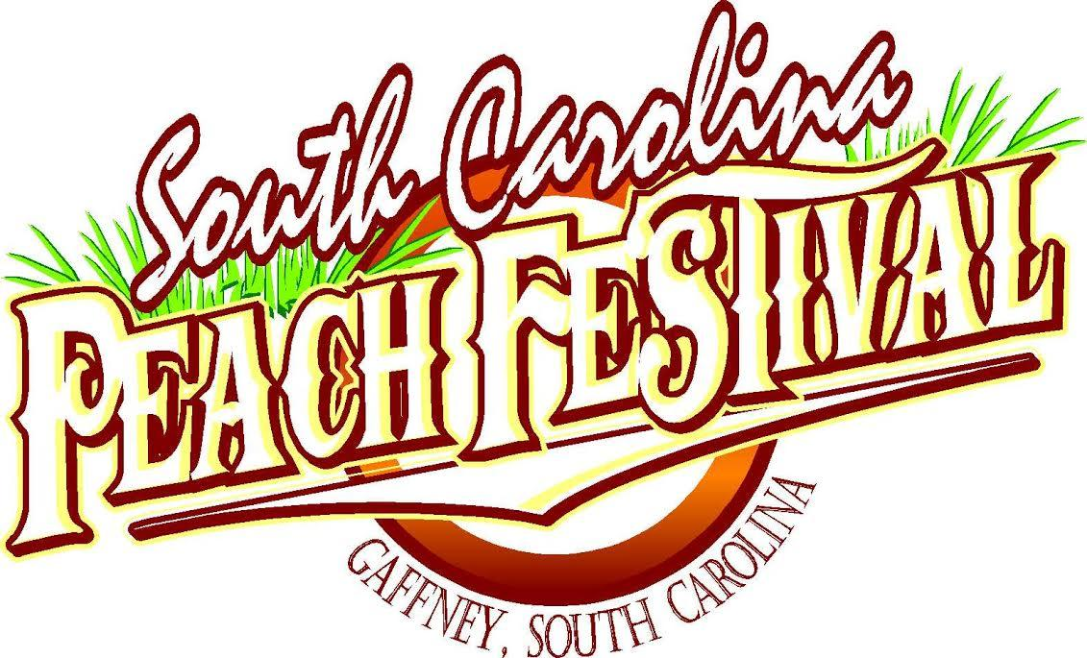

July 2019
www.scpeachfest.net

The Peachoid Sponsor $8,000.00

▪ Advertising Presence on Festival Website
▪ WZZQ Promotion during Kick-off
▪ Cherokee County Chamber of Commerce Promotion
▪ Publicity on Official SC Peach Festival Facebook Page
▪ Advertising Presence in all local print media and at all Events
▪ Logo/Name on Downtown Banner
▪ 8 Passes for all ticket events
▪ 8 Peach Festival Shirts
▪ 1 10’ X 10’ Vendor Space
▪ 1 Peach Festival Parade Float
▪ 4 Exclusive Sponsorship Parking at Lake Whelchel
▪ 30 second Video with Peach Festival Mascot “Peachy”

Peach Tree sponsor $6,000.00

▪ Advertising Presence on Festival Website
▪ WZZQ Promotion during Kick-off
▪ Cherokee County Chamber of Commerce Promotion
▪ Publicity on Official SC Peach Festival Facebook Page
▪ Advertising Presence in all local print media and at all Events
▪ Logo/Name on Downtown Banner
▪ 5 Passes for all ticket events
▪ 5 Peach Festival Shirts
▪ 1 10’ X 10’ Vendor Space
▪ 1 Peach Festival Parade Float
▪ 3 Exclusive Sponsorship Parking at Lake Whelchel
▪ 20 second Video with Peach Festival Mascot “Peachy”

Big Peach Sponsor $3000.00

▪ Advertising Presence on Festival Website
▪ WZZQ Promotion during Kick-off
▪ Cherokee County Chamber of Commerce Promotion
▪ Publicity on Official SC Peach Festival Facebook Page
▪ Advertising Presence in all local print media and at all Events
▪ Logo/Name on Downtown Banner
▪ 3 Passes for all ticket events
▪ 3 Peach Festival Shirts
▪ 1 10’ X 10’ Vendor Space
▪ 1 Peach Festival Parade Float
▪ 3 Exclusive Sponsorship Parking at Lake Whelchel

Little Peach Sponsor $2000.00

▪ Advertising Presence on Festival Website
▪ WZZQ Promotion during Kick-off
▪ Cherokee County Chamber of Commerce Promotion
▪ Publicity on Official SC Peach Festival Facebook Page
▪ Advertising Presence in all local print media and at all Events
▪ Logo/Name on Downtown Banner
▪ 2 Passes for all ticket events
▪ 2 Peach Festival Shirts
▪ 1 10’ X 10’ Vendor Space
▪ 1 Peach Festival Parade Float
▪ 2 Exclusive Sponsorship Parking at Lake Whelchel

Peach Blossom $1000.00

▪ Advertising Presence on Festival Website
▪ WZZQ Promotion during Kick-off
▪ Cherokee County Chamber of Commerce Promotion
▪ Publicity on Official SC Peach Festival Facebook Page
▪ Advertising Presence in all local print media and at all Events
▪ Logo/Name on Downtown Banner
▪ 2 Passes for all ticket events
▪ 2 Peach Festival Shirts
▪ 1 10’ X 10’ Vendor Space
▪ 1 entry in Peach Festival Parade

Peach Pit $500.00

▪ Advertising Presence on Festival Website
▪ WZZQ Promotion during Kick-off
▪ Cherokee County Chamber of Commerce Promotion
▪ Publicity on Official SC Peach Festival Facebook Page
▪ 1 entry in Peach Festival Parade

Schedule of Events

July 18th, Thursday Starting at 7pm
7pm - New Talent Night - Limestone College Fullerton Auditorium

July 19th, Friday starting at 5pm to 11pm
- 5pm to 10pm, Kickoff Party - Amphitheater (Downtown Gaffney)
- Music, Food Vendors, Carnival, Amphitheater (Downtown Gaffney)
7pm to 11pm Mud Bog (Lake Whelchel), Carnival and food vendors
▪ Truck Gates Open at 12 noon
▪ Spectator Gates Open at 5 pm

July 20th, Saturday starting at 7am to 10pm
▪ 7:30 am Road Race 5K and 10K (Limestone College)
▪ 9am 1-mile- Fun Run (Limestone College)
- 10am South Carolina Peach Festival Parade (Downtown Gaffney)
▪ 2pm Peach Festival Pageant (Limestone College)
▪ Events downtown - the Capri theatre, and Amphitheater
- Food Vendors, Carnival - Amphitheater (Downtown Gaffney)
- 12pm - Abbott Farms Peach Dessert Contest, Gaffney City Hall
✓ 12pm - Car and Bike Show (Downtown Gaffney)
✓ 9am - Arts and Crafts, First Baptist Church, Amphitheater (Downtown Gaffney)
✓ 12pm - Music and entertainment - Amphitheater, Capri Theater
✓ 5pm -Headline Concert at Amphitheater (Downtown Gaffney)

July 21st, Sunday starting at 1pm
Community Praise and Worship
Amphitheater, Downtown Gaffney

Corporate Sponsorship Commitment Form

Please print all names legibly and exactly as they should appear in all publications.

Business Name: ____________________________________________ (as it appears in print)
Contact Name: ___________________________________________________________________________
Mailing address: ____________________________________________________________
City / State / Zip: _____________________________________________
Phone: ____________________________________

Type of contribution (please mark one):
Cash/Check Sponsorship Dollar Amount: $____________
In Kind Item(s) Donated: _____________

Please mark and return for benefits according to level.

Sponsorships received before June 14th, 2019, will be recognized according to levels. We are a 501(c) 6 and our tax ID is 57-0707232. Please enclose a check payable to The South Carolina Peach Festival. We thank you for your contribution.

_____________________________________________________
Signature of sponsor.

Please email the logo in jpg format for promotional use to crbridges@ymail.com. For questions or concerns, please contact Carlton Bridges Sr. @ 864-838-1705.

Please sign the form and return to:

THE SOUTH CAROLINA PEACH FESTIVAL, INC.
210 West Frederick Street Gaffney SC 29341

P.O. BOX 549
GAFFNEY, SC 29342

www.scpeachfest.net, 2019 Benefit Form

______ Parade Entry ______ Vendor Space / Shirt Sizes, Qty, Small _____ Medium _____ Large _____ X-Large _____ XX-Large _____ XXX-Large _____ *

Please select the benefits for your level that you plan to participate in. Also, complete and return the appropriate forms for the respective benefits.

